Microsoft Windows [Version 19.0.26290.9168]
(c) Microsoft Corporation. All rights reserved .
\users \ DELL>mongosh
Current Mongosh Log ID: 6a96876a3dU9f69cU+57df72
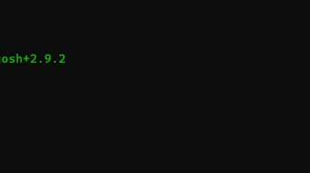
Connecting to: mongodb : / /127 . O. e . 1 : 27817/?directConnection=true&serverSeIectionTimeoutMS=2eOOGappName=mongosh+2.9.2
Using MongoDB: 8.3 . 7 Using Mongosh: 2.9. 2 mongosh 2.10.9 is available for download: https : //www.mongodb.com/try/download/shell
For mongosh info see: https : //www.mongodb.com/docs/mongodb—shell/
The | server | generated | these | startup warnings when booting  Access control is not enabled for the database. Read and write access to data and configuration is unrestricted
C:
